Table of Contents

List of Figures ii

Research Question 1

Report Part A 2

Exploratory Analysis 2

Data Story 4

Visualizations 6

Report Part B 9

Critical Reflection 9

Data Acquisition & Metadata 9

Data Columns 9

Data Preparation 10

Data Segmentation 10

Transforming Data 11

Power BI Graphics Interface 12

What I did Well 13

Report Conclusion 13

Recommendation 13

# List of Figures

Figure 1 Summary of Data Exploration 3

Figure 2 Showing Incident Type by Total Incident 6

Figure 3 Showing the percentage of Incident by Landscape (Urban Rural) 6

Figure 4 Showing Total Incident by Metropolitan and Non-Metropolitan 7

Figure 5 Shows Total Incident by Incident Type and Landscape (Rural & Urban) 7

Figure 6 Geographical Map showing the Regions with Fire Incidents 8

Figure 7 Bar chart showing Total Incident count by region 8

Figure 8 Data Segmentation in Power BI 10

Figure 9 Data Transformation in Power BI 11

Figure 10 Power BI Interface showing visualizations (a) 12

Figure 11 Power BI Interface showing visualizations (b) 12

# Research Question

How do fire incident response patterns differ between densely populated urban areas and less densely populated rural areas?

# Report Part A

## Exploratory Analysis

This section presents a detailed exploratory analysis of an extensive fire incident dataset spanning 14 years, comprising a total of approximately 7 million incidents. The dataset encompasses 11 distinct incident types, recorded across various regions, with 44 different Emergency Codes (E-Codes) and a comprehensive breakdown of rural-urban classifications. Additionally, the dataset includes information on the involvement of 44 Fire and Rescue Service (FRS) responders. The analysis aims to provide insights into the patterns, trends, and key characteristics of fire incidents over the specified period.

The dataset under examination captures a wealth of information related to fire incidents that occurred over a 14-year timeframe. With a staggering total of approximately 7 million incidents, this dataset is a valuable resource for understanding the dynamics and nuances of fire-related emergencies.

**Dataset Overview**

The dataset encompasses 11 incident types, offering a diverse representation of fire-related events. Each incident is further classified with Emergency Codes (E-Codes), totaling 44 unique codes. The dataset also provides a geographical perspective through the Rural-Urban classification, which is divided into three distinct categories. Moreover, data on 44 Fire and Rescue Service (FRS) responders are included, contributing to a comprehensive understanding of emergency response efforts.

**Temporal Trends**

An examination of temporal trends reveals patterns and fluctuations in the occurrence of fire incidents over the 14-year period. Seasonal variations, long-term trends, and notable spikes in incidents are explored to provide context and aid in the development of targeted preventive measures.

**Incident Type Analysis**

A detailed breakdown of the 11 incident types sheds light on the distribution and prevalence of specific fire emergencies. This analysis identifies high-impact incident types, facilitating prioritization in resource allocation and response planning.

**Geographic Insights**

The Rural-Urban classification allows for a nuanced examination of fire incidents across different settings. Understanding the geographical distribution of incidents aids in tailoring prevention and response strategies to address the specific challenges posed by rural and urban environments.

**Emergency Code Patterns**

An in-depth exploration of the 44 Emergency Codes provides insights into the severity and nature of fire incidents. This analysis contributes to the development of a standardized coding system and enhances communication and coordination among emergency responders.

**FRS Response Analysis**

The involvement of 44 Fire and Rescue Service (FRS) responders is a critical aspect of the dataset. This section evaluates response times, coordination efforts, and the effectiveness of FRS interventions in mitigating the impact of fire incidents.

In conclusion, this exploratory analysis of the fire incident dataset offers a comprehensive understanding of the dynamics surrounding fire emergencies over a 14-year period. The findings provide valuable insights for policymakers, emergency responders, and researchers, aiding in the development of informed strategies for fire prevention and response.

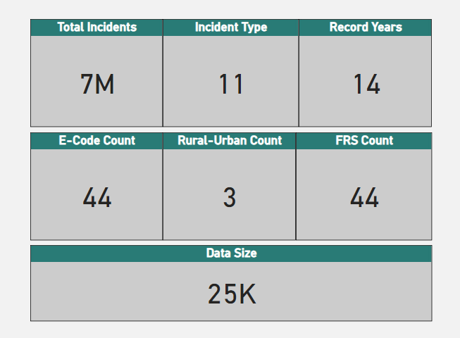

Figure 1 Summary of Data Exploration

## Data Story

The exploration of fire incidents unveils critical patterns and challenges faced by firefighting teams in urban and rural landscapes. Analyzing incident data reveals disparities in responses, emphasizing the unique nature of incidents in predominantly urban and significantly rural areas. This report delves into incident patterns, response volumes, and regional variations to provide insights for tailored firefighting strategies, ensuring efficient incident responses and community safety.

In the exploration of fire incidents, data becomes a crucial tool in deciphering the complex tapestry of challenges faced by firefighting teams. Figure 2 and Figure 3 provide a lens into the urban and rural landscapes, unravelling patterns and disparities in fire responses.

Within Predominantly Urban areas, a staggering 1,242,961 incidents are attributed to "Due to apparatus," constituting 33.9% of the total. Non-fire incidents follow closely, accounting for 27.7%, while Secondary Fires make up 21.5% of the urban incidents. Dwellings and Road Vehicles also emerge as significant contributors, underlining the diverse nature of challenges faced in city environments (Figure 5).

On the other hand, Significantly Rural areas exhibit a different set of patterns. "Non-fire incidents" and incidents "Due to apparatus" lead the way, comprising 28.2% and 24.2%, respectively. Notably, "Good intent" incidents persist in rural regions at 13.3%, emphasizing the need for response strategies beyond traditional fire emergencies (Figure 5). Dwellings and Secondary Fires play pivotal roles in rural incidents, illustrating the unique challenges faced by less urbanized areas.

Expanding the analysis to the urban-rural dimension, Non-metropolitan areas account for a total of 1,832,667 incidents, dominating the scene. Within Non-metropolitan areas, Significantly Rural regions claim a substantial majority at 69.9%, highlighting the prevalence of fire incidents in less densely populated settings. Conversely, Metropolitan areas, while experiencing fewer incidents (1,621,379 in total), exhibit a concentration of incidents in Predominantly Urban settings at 68.6%, signifying the intensity of firefighting challenges within city limits. (Figure 4 & Figure 8)

In addition, it is evident that the scale of incident responses varies significantly among regions (Figure 7). Greater London stands out in Europe with a substantial 1,426,922 incidents, representing a considerable proportion of the total responses. In contrast, regions like the Isles Of Scilly record a much smaller count of 296 incidents, highlighting the diversity in incident volumes across different locales (Figure 6 & Figure 7).

Greater London records 1,426,922 (33.4% of total incidents), Greater Manchester records 418,627 (9.8% of total incidents), West Midlands records 363,869 (8.5% of total incidents), West Yorkshire records 327,221 (7.7% of total incidents) and so forth for the remaining regions (Figure 6 & Figure 8).

The data highlights that urban areas, including Greater London, Greater Manchester, and the West Midlands, exhibit higher incident response volumes, with percentages ranging from 7.7% to 33.4%. These figures show the heightened demand on FRS teams in densely populated regions (Figure 6 & Figure 8).

Conversely, regions with a smaller population density, such as the Isles Of Scilly, account for a minor percentage of incidents, approximately 0.004% (Figure 6). This may prompt further investigation into the nature of incidents in sparsely populated regions and the corresponding response strategies.

The disparity in incident types across urban and rural areas raises intriguing questions about the factors influencing these patterns. For instance, the prevalence of "Due to apparatus" incidents in Predominantly Urban areas might be associated with the complexity of city infrastructure, suggesting a need for specialized equipment or training for urban firefighting teams. On the contrary, the dominance of "Non-fire incidents" in Significantly Rural areas could indicate challenges related to non-emergency situations, necessitating community education or preventive measures.

Examining the percentages in more detail reveals nuanced insights into the geographical distribution of incidents. The concentration of incidents in Greater London, accounting for one-third of the total responses, prompts considerations of the city's unique characteristics, such as population density, architectural layout, or economic activities, influencing the frequency of incidents. Conversely, the Isles of Scilly's minute contribution raises questions about the effectiveness of current preventive measures or the nature of incidents in remote, sparsely populated regions.

Based on the comprehensive analysis of fire incidents, it is recommended that firefighting teams in predominantly urban areas prioritize specialized training and equipment to address the prevalence of “due to apparatus” incidents. Conversely, teams in significantly rural regions should focus on community education and preventive measures to tackle the challenges associated with “Non fire incidents.” Tailoring strategies based on these insights will enhance incident response efficiency and overall community safety

In conclusion, this extended analysis not only provides a detailed account of incident patterns but also invites further exploration into the underlying dynamics influencing these patterns. By considering the unique challenges posed by urban and rural landscapes, as well as variations among different regions, firefighting teams can better tailor their strategies to ensure efficient incident response and community safety.

## Visualizations

This section contains the visuals as referenced in the Data Story section.

Figure 2 Showing Incident Type by Total Incident

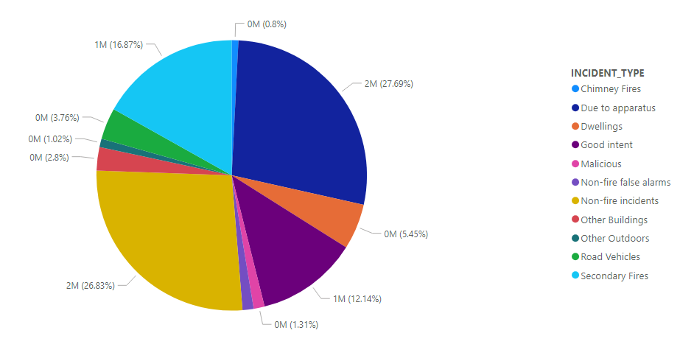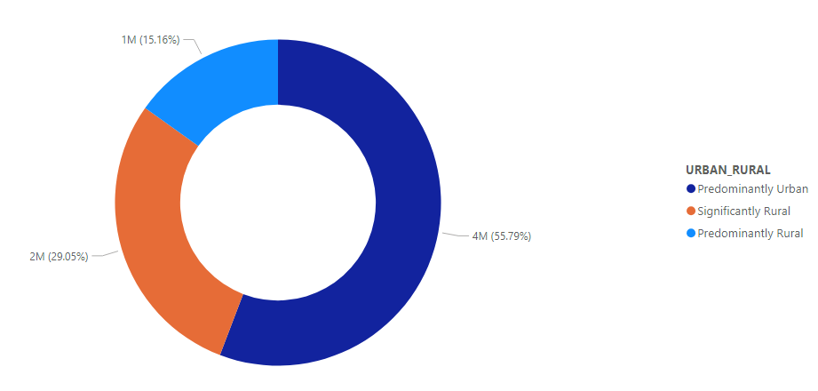

Figure 3 Showing the percentage of Incident by Landscape (Urban Rural)

Figure 4 Showing Total Incident by Metropolitan and Non-Metropolitan

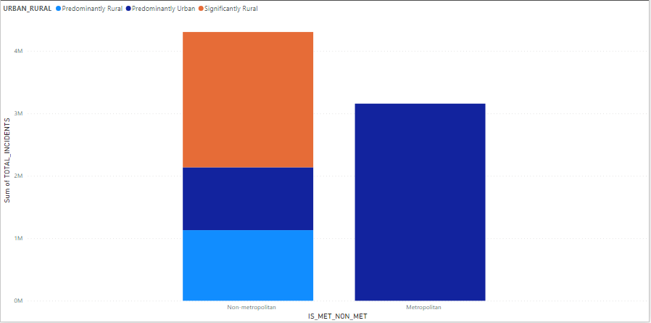

Figure 5 Shows Total Incident by Incident Type and Landscape (Rural & Urban)

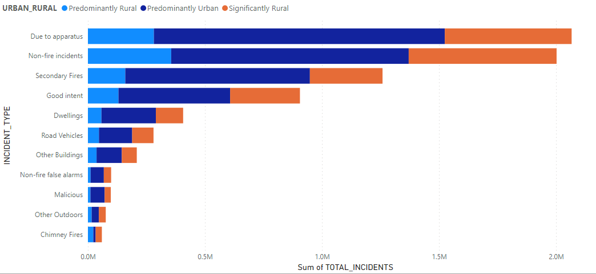

Figure 6 Geographical Map showing the Regions with Fire Incidents

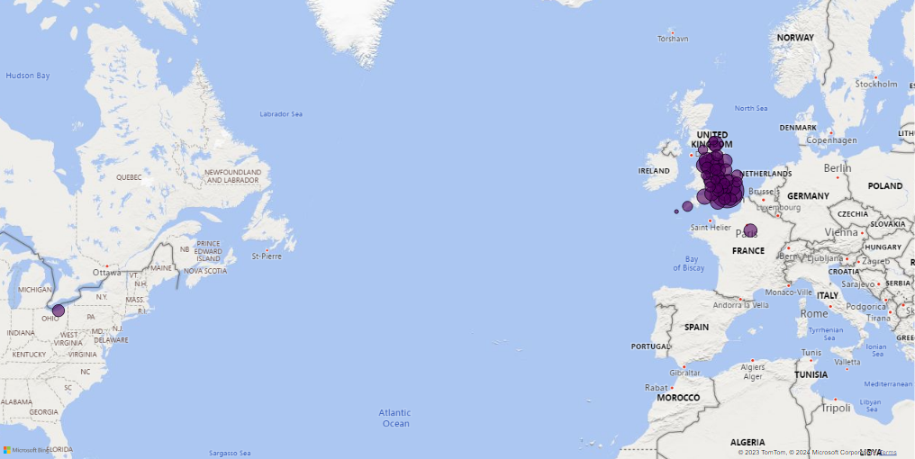

Figure 7 Bar chart showing Total Incident count by region

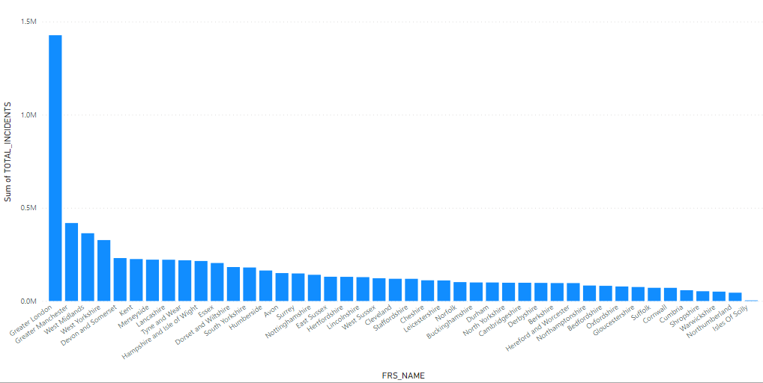

# Report Part B

## Critical Reflection

In synthesizing these insights, the totality of fire incidents reveals a nuanced narrative. Urban areas, with a total of 2,131,779 incidents, face a myriad of challenges, each incident type demanding tailored responses. Predominantly Urban settings contribute 26.7% of the overall incidents, while Predominantly Rural areas play a comparable role at 26.8%, emphasizing the importance of understanding the diversity within urban and rural landscapes.

Rural areas, comprising 1,832,667 incidents, showcase a distinct set of challenges. Significantly Rural regions contribute significantly, constituting 32.5% of overall incidents, underlining the need for specialized strategies to address the unique characteristics of less urbanized locales.

In the evolving landscape of fire response, understanding these urban-rural dynamics becomes paramount. Fire response units can leverage this insight to formulate more effective and targeted strategies, ensuring the safety and resilience of communities in the face of diverse fire incidents.

Understanding the distribution of incident responses is crucial for optimizing resource allocation and devising targeted strategies. The disparities among regions, both in terms of incident volumes and percentages, highlight the need for tailored response plans to address the unique challenges faced by each community. Fire and Rescue Services can leverage this data to enhance preparedness, ensuring swift and effective responses, and ultimately safeguarding communities across diverse landscapes.

## Data Acquisition & Metadata

**Data Source:** <https://www.gov.uk/government/statistical-data-sets/fire-statistics-data-tables>

**Title:** Incidents attended by fire and rescue services in England, by incident type and fire and rescue authority.

**Details:** Shows the number of incidents attended by type of incident and fire and rescue authority for financial years.

England, year ending June 2023: data tables

Table 0102

**Published:** 26 October 2023

### Data Columns

1. FINANCIAL_YEAR
2. YEAR_QUATER
3. FRS_NAME
4. E_CODE
5. IS_MET_NON_MET
6. URBAN_RURAL
7. INCIDENT_TYPE
8. TOTAL_INCIDENTS

## Data Preparation

Data Preparation was performed using Microsoft Excel and Power BI.

### Data Segmentation

To obtain a clearer overview of the dataset, the dataset was segmentated by relevant columns. Data segmentation involves dividing a larger dataset into smaller, more maneagable segments based on specific crieteria such as demographics, and other relevant facgtors. process helps to analyze and target specific subsets of data for more effectiveanalysis and decision-making.

Figure 8 Data Segmentation in Power BI

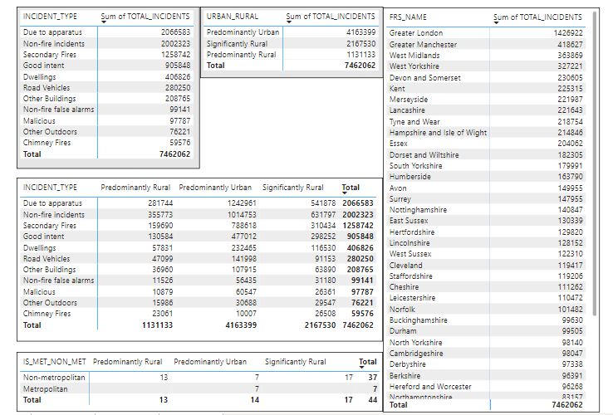

### Transforming Data

The data is a clean data. However, the FINANCIAL_YEAR column type was changed to Date Type.

Figure 9 Data Transformation in Power BI

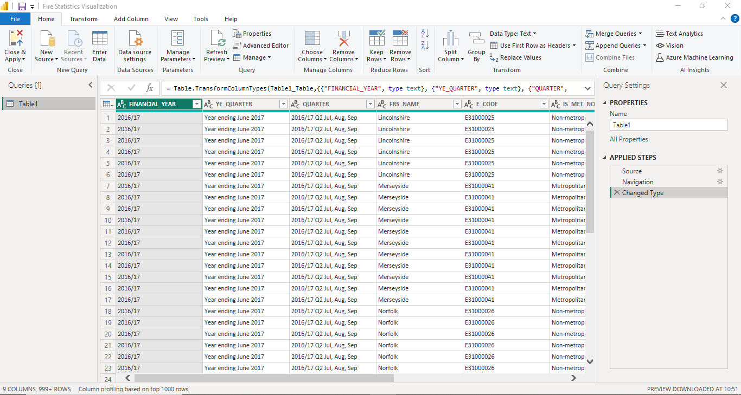

More so, New Measures were created such as:

1. Data_Count
2. E_CODE_COUNT
3. FINANCIAL_YEAR_COUNT
4. FRS_NAME_COUNT
5. INCIDENT_TYPE_COUNT
6. URBAN_RURAL_COUNT

### Power BI Graphics Interface

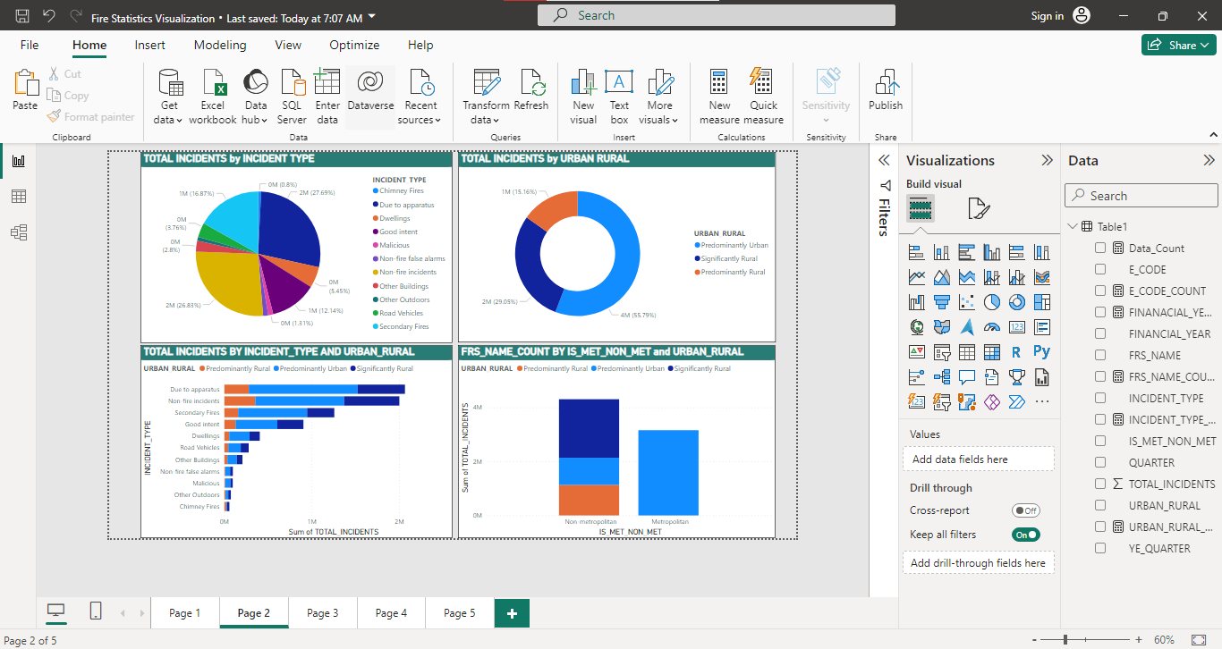

Figure 10 Power BI Interface showing visualizations (a)

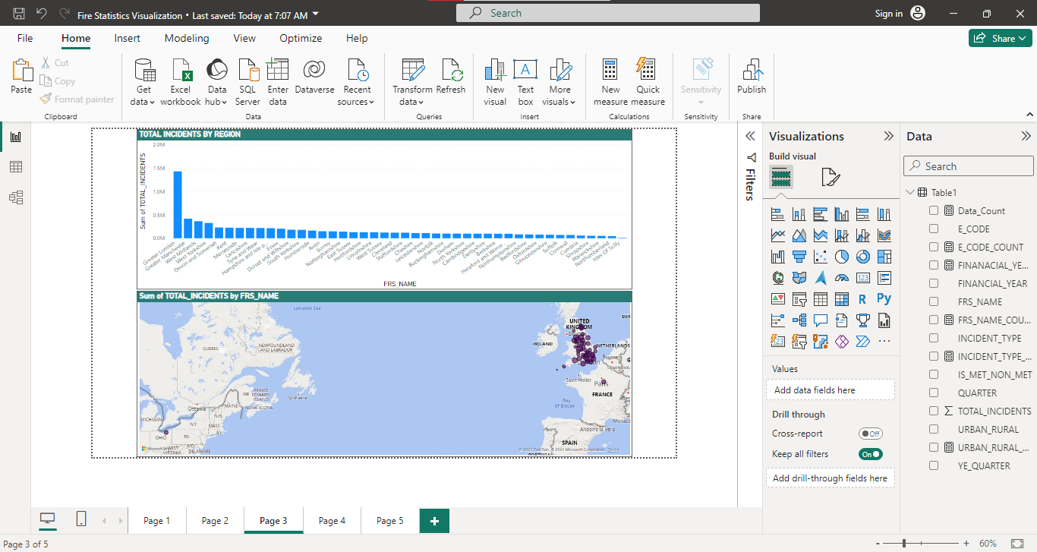

Figure 11 Power BI Interface showing visualizations (b)

## What I did Well

Segmenting the Data gave me a better understanding of the data (Figure 8).

# Report Conclusion

The comprehensive examination of fire incidents presented in this report offers valuable insights into the diverse challenges faced by firefighting teams across urban and rural landscapes. The data highlights distinct patterns in incident types and response volumes, emphasizing the need for nuanced strategies tailored to specific environments. The prevalence of "Due to apparatus" incidents in Predominantly Urban areas and the dominance of "Non-fire incidents" in Significantly Rural areas raise questions about the unique factors influencing these patterns.

The regional analysis highlights significant variations, with Greater London standing out with a substantial share of incidents, while regions with lower population density contribute minimally. This prompts considerations of the influence of factors such as population density, infrastructure complexity, and economic activities on incident frequency.

The disparities observed necessitate further investigation into the nature of incidents in sparsely populated regions and the effectiveness of preventive measures. Additionally, the concentration of incidents in Greater London prompts a deeper exploration of the city's unique characteristics and their impact on incident occurrence.

This extended analysis not only enhances our understanding of incident patterns but also serves as a call for continued exploration into the underlying dynamics shaping these patterns. By recognizing the diverse challenges posed by different landscapes and regions, firefighting teams can refine their strategies to ensure more efficient incident response and community safety. The findings of this report provide a foundation for future research and the development of targeted interventions to address the specific needs of varying firefighting environments.

# Recommendation

To improve data story and visualization, I would ensure visualizations are clearer and easily understandable by providing both significant figures and percentages on the charts in consistent manner as highlighted in the data story. And when possible incorporate interactive elements in the visualization.